Task 10 : Create a Docker image and push it to Docker hub using CI-CD.

I completed this take by using AWS Cloud.

Step 1: Create an EC2 instance. Here I Used Ubuntu OS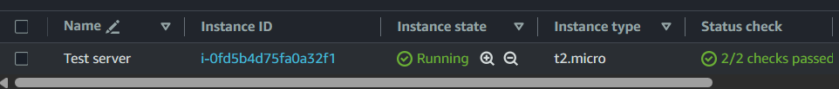

Step 2: Install Java and verify if it is installed or not



Step 3: Install Jenkins

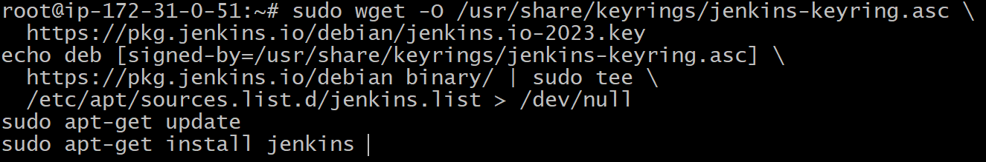

Step 4: Unlock Jenkins by extracting the password

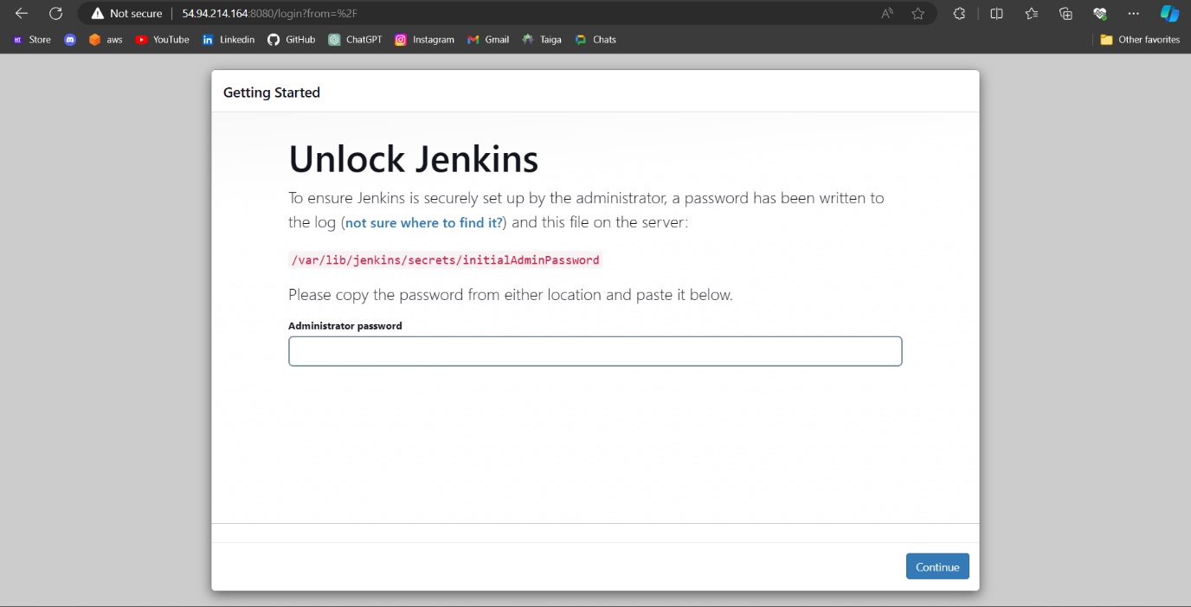



Step 5: Choose “Install Suggested Plugins”

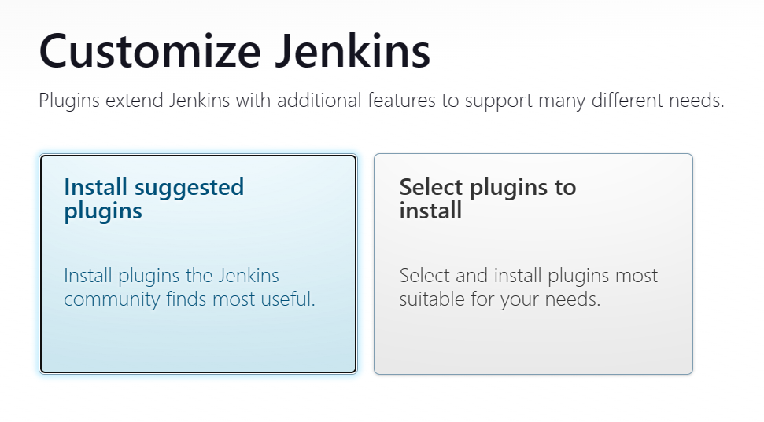

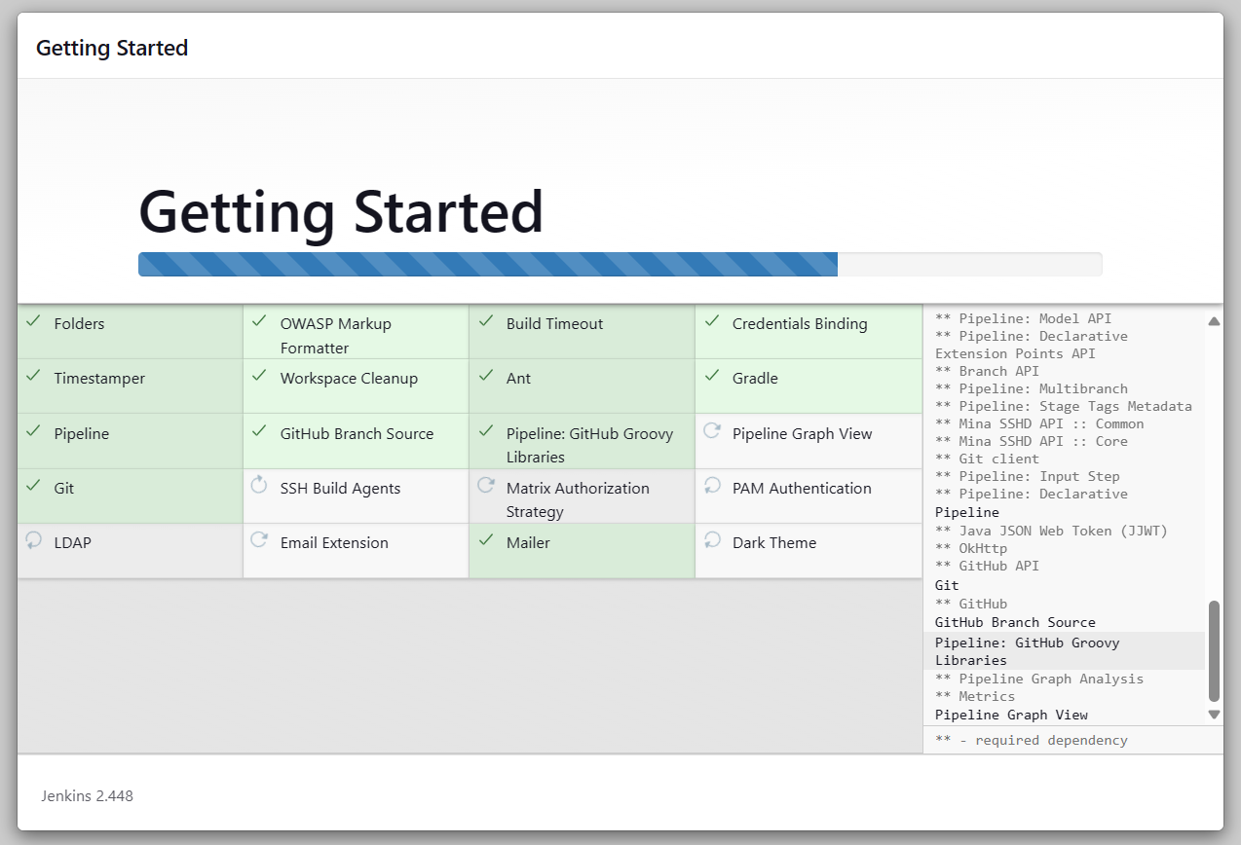

Step 6: Create First Admin User

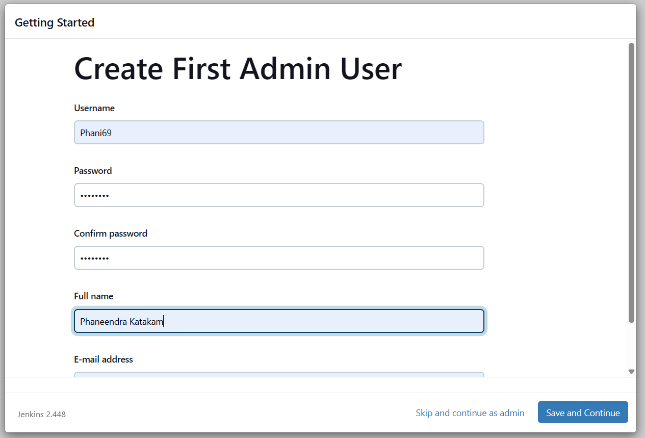

Now the Jenkins installation is done.

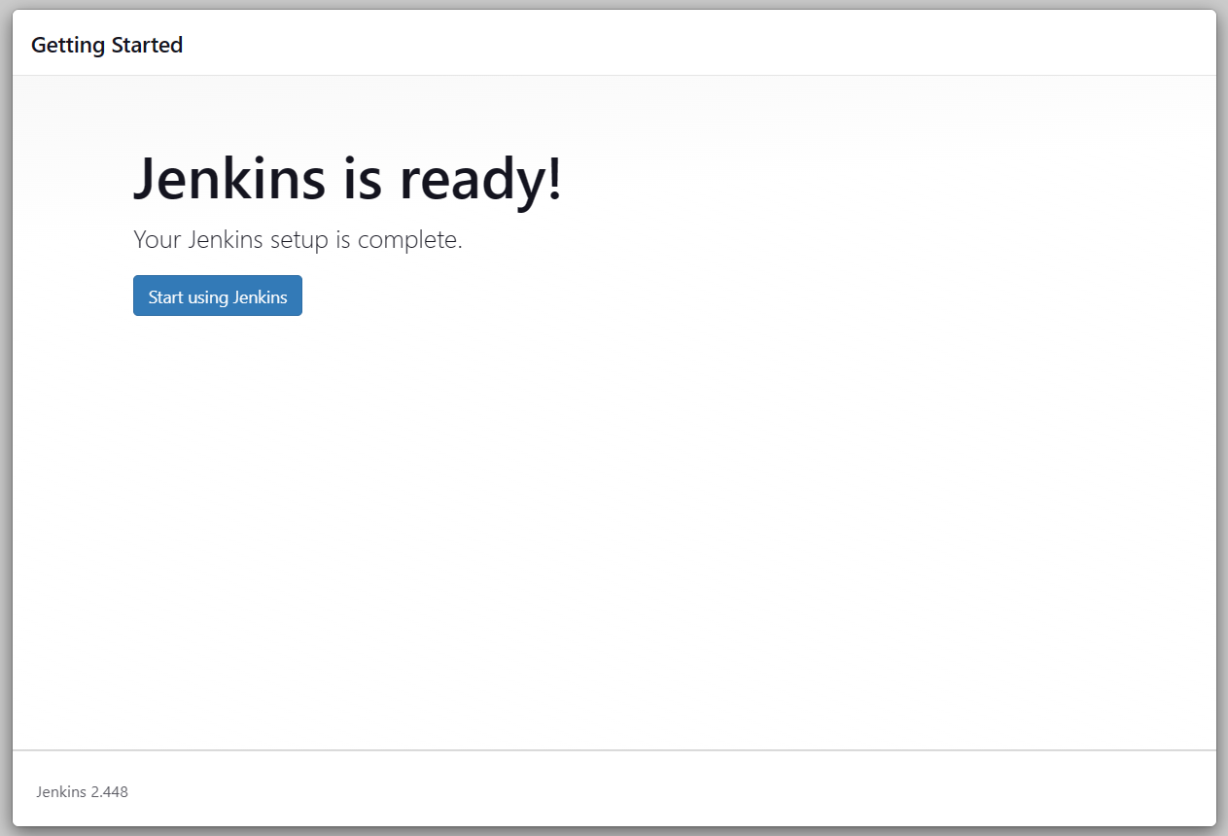

Step 7: Now head to the “Plugins” and install required plugins.

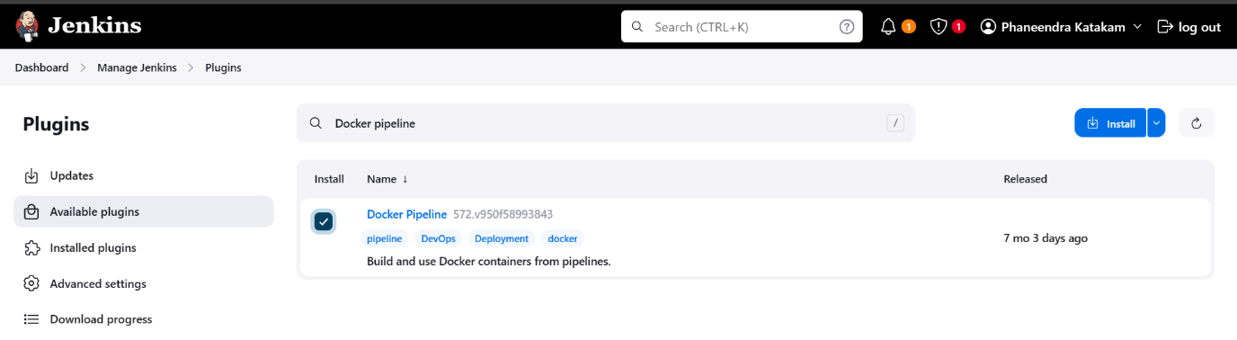

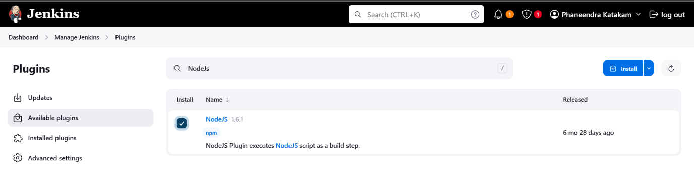

After installing the required plugins, restart the Jenkins.

Step 8: Now install Docker and setup Docker Slave Configuration.



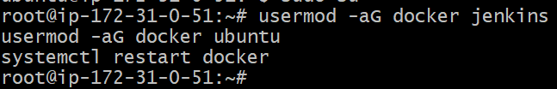

Again restart the Jenkins once.

Strep 9: Head to the “Credentials” section to configure GitHub and Docker Hub credentials.

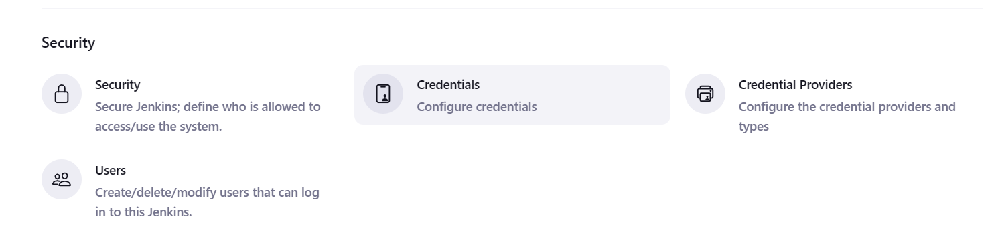

And configure the credentials

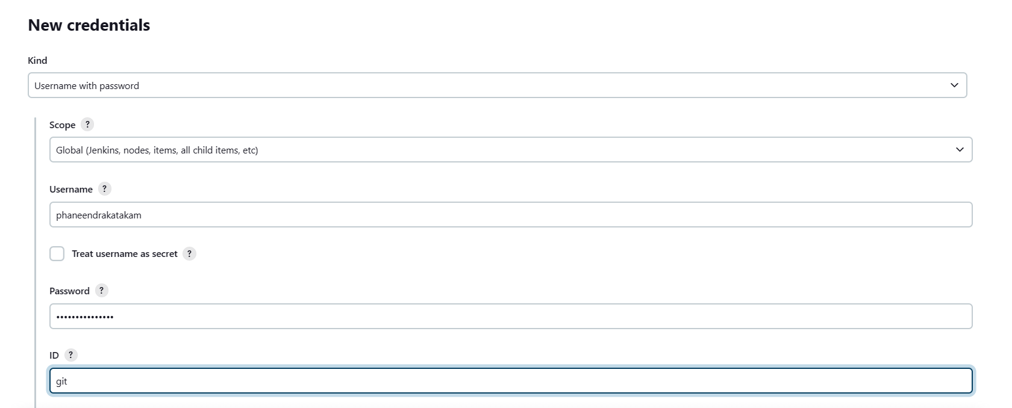

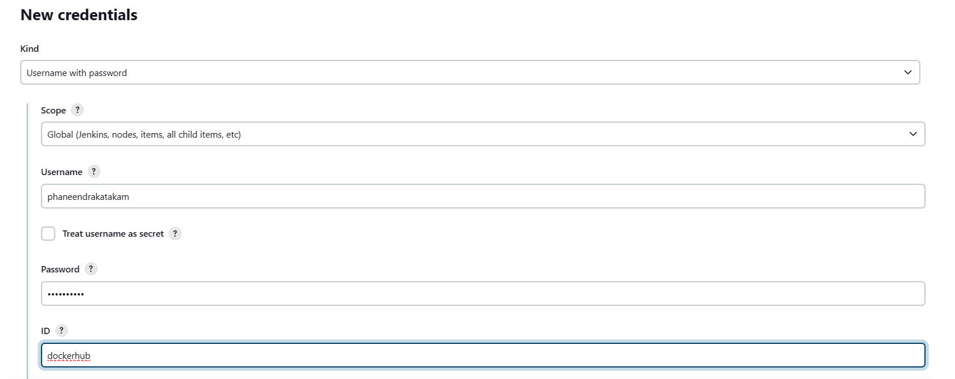

We are done with all the prerequisites, now start creating a job.

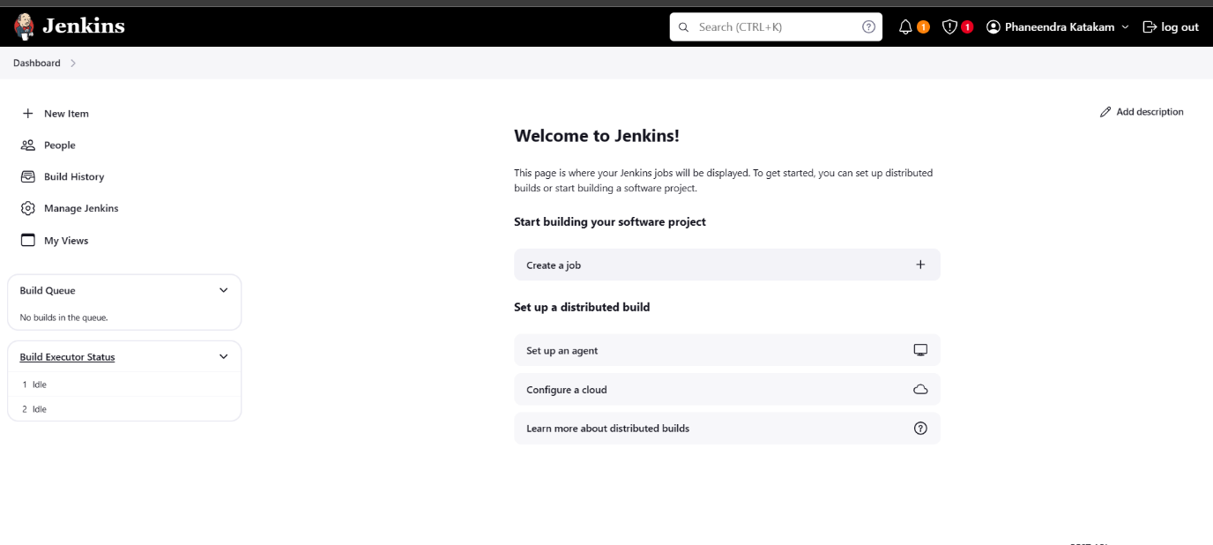

Step 10: Give the job a name and select “Pipeline” and then “OK”

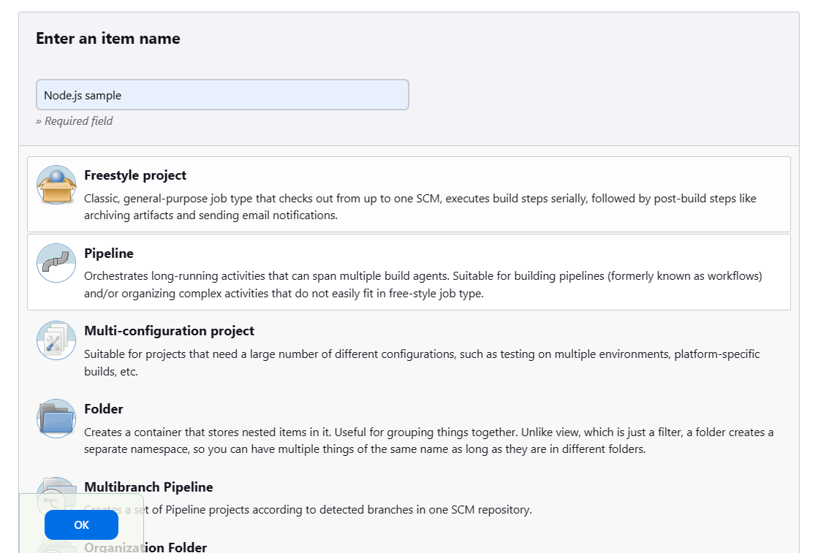

Step 11: Head to the “Pipeline” option and configure “pipeline scripy from SCM” and “Git” and select Repository where the Jenkinsfile located and give appropriate credentials and save the file.

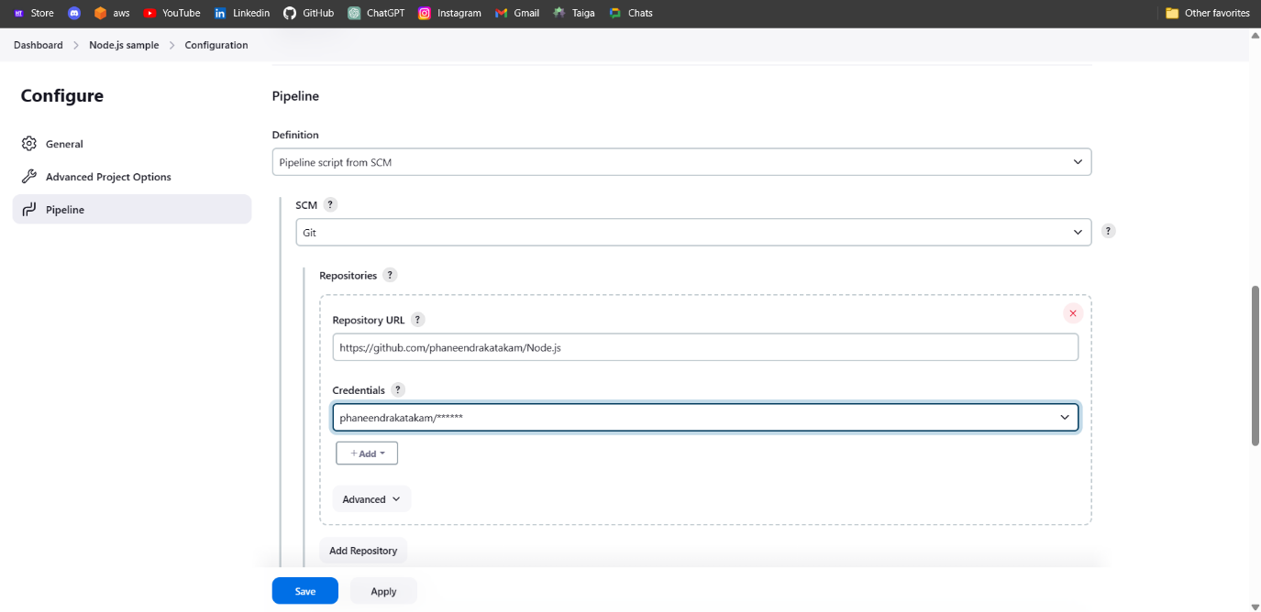

Step 12: Start building process and observe console output.

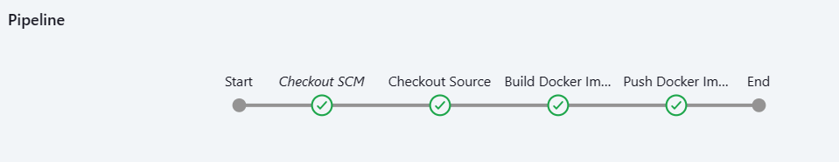

This indicates that the build process is success.

Step 13: Head to the Docker Hub and check the repository for the image.

